ACKNOWLEDGEMENT

First and foremost, I wish to place on records my ardent and earnest gratitude to my seminar guide Prof. Jasmin.S, Assistant Professor, Dept. of Computer Science and Engineering . His tutelage and guidance was the leading factor in translating my efforts to fruition. His prudent and perceptive vision has shown light on my trail to triumph.

I would like to express my sincere thanks to our respected Principal in charge
Prof. RAFI A for the facilities provided for presenting this seminar.

I am extremely happy to mention a great word of gratitude to Prof. SAHEER H., Head of the Department of Computer Science and Engineering for providing me with all facilities for the completion of this work.

Finally yet importantly, I would like to express my gratitude to my Seminar Coordinator Prof.Shibinisha Shahul, Assistant Professor, Dept. of Computer Science and Engineering for her valuable assistance provided during the course of the seminar.

I also extend my gratefulness to all the staff members in the Department. I also thank all my friends and well-wishers who greatly helped me in my endeavour.

MOHAMMED ADHIL ASHIK
ABSTRACT

Indoor air pollution poses significant risks to human health, particularly in educational settings where occupants spend prolonged periods indoors. Poor indoor air quality (IAQ) can exacerbate respiratory illnesses, cause discomfort, and reduce cognitive performance. This seminar focuses on the design and implementation of an IoT-based IAQ monitoring and management system tailored for intelligent education environments. The primary objective is to demonstrate how low-cost, self-manufactured IoT devices, integrated with advanced data processing technologies, can effectively detect, predict, and manage indoor pollutants. The study employed a wireless sensor network to collect real-time data on CO₂, PM₂.₅, total volatile organic compounds (TVOCs), temperature, and humidity in university lecture and laboratory rooms. Data was transmitted via ZigBee to a low-code platform, processed by a complex event processing (CEP) engine, and analyzed using long short-term memory (LSTM) neural networks for forecasting pollutant levels and decision tree regressors for exploring parameter relationships. Relevant IAQ events were stored on a blockchain for secure and transparent record-keeping. A case study demonstrated the system’s capability to detect hazardous conditions, predict short-term pollutant fluctuations, and provide actionable insights for timely interventions. Results indicate high predictive accuracy, particularly for PM₂.₅ and temperature, and reveal a positive correlation between CO₂ levels and particulate matter concentrations. The seminar concludes that such an integrated IoT–AI–blockchain approach can enhance health and productivity in learning environments, with potential scalability to other indoor spaces and future integration of transformer-based forecasting models.

 | CONTENTS
Chapter No | Title | Page No
 | List of Abbreviation | iii
 | List of Figures | iv
1 | Introduction | 1
2 | Literature Review | 3
3 | BCI Framework & Signal Acquisition | 6
3.1 | System Overview | 7
3.2 | Signal Acquisition Modalities | 7
3.3 | Feature Extraction And Decoding | 8
3.4 | Feedback And Adaptation | 9
4 | Difference between Invasive And Non- Invasive BCIs | 10
4.1 | Introduction | 10
4.2 | Invasive BCI Overview | 10
4.3 | Non-Invasive BCI Overview | 10
4.4 | Comparative Analysis | 11
5 | Non-Invasive Techniques & Signals | 13
5.1 | Non-Invasive Recording Methods | 13
5.2 | Major Non-Invasive Signal Types | 14
5.3 | Advantages And Limitations | 16

6 | Algorithm And Toolboxes | 18
6.1 | Signal Preprocessing | 18
6.2 | Feature Extraction | 18
6.3 | Decoding Algorithms | 19
6.4 | BCI Toolboxes And Software platform | 19
7 | Applications Of BCI | 21
7.1 | Clinical Rehabilitation Applications | 21
7.2 | Assistive Device Control | 22
7.3 | Consumer And Entertainment users | 22
7.4 | Research And Industrial Applications | 22
7.5 | Representative Cases Studies | 23
8 | Challenges & Future Scope | 25
8.2 | Human And Ethical Considerations | 26
8.3 | Future Research Directions | 26
9 | User Training Strategies In Non-Invasive BCIs | 28
9.1 | Overview And Importance | 28
9.2 | Training Procedures And Feedback | 28
9.3 | Research Outcomes And Future Directions | 29
10 | Conclusion | 31
 | References | 32

LIST OF ABBREVIATIONS

BCI - Brain–Computer Interface
EEG - Electroencephalography
ECoG - Electrocorticography
MEG - Magnetoencephalography
fNIRS - Functional Near-Infrared Spectroscopy
CSP - Common Spatial Patterns
VR - Virtual Reality
AR - Augmented Reality

LIST OF FIGURES

Figure No Title Page No

3.1 | BCI Framework | 6
5.1 | Comparison diagram of  invasive vs. non-invasive signal acquisition | 14
5.2 | Signal acquisition and pre- processing pipeline | 16
8.1 | pplications of non-invasive BCIs | 24

CHAPTER 1 INTRODUCTION
Indoor Air Quality (IAQ) has emerged as a crucial factor influencing human health, comfort, and performance in enclosed environments. In modern societies, people spend nearly 90% of their time indoors, making the quality of air inside buildings directly connected to overall well-being. The World Health Organization (WHO) estimates that around 3.8 million deaths per year are linked to indoor air pollution, emphasizing its severe impact on public health. Poor IAQ has been associated with respiratory illnesses, fatigue, headaches, allergies, and reduced concentration levels, which can significantly affect productivity and learning efficiency.

Among various indoor spaces, educational institutions such as schools and universities require special attention. Students are particularly vulnerable because they spend long hours in classrooms, often in enclosed spaces with limited ventilation. Elevated levels of pollutants such as carbon dioxide (CO₂), particulate matter (PM2.5), volatile organic compounds (VOCs), humidity, and temperature imbalances can degrade not only student health but also academic performance. High CO₂ concentrations, for example, are directly linked to drowsiness, reduced focus, and slower cognitive processing, all of which hinder learning outcomes. Therefore, ensuring healthy air quality in educational spaces is both a public health requirement and a learning necessity.

Traditional IAQ monitoring systems are limited in scope. Many are expensive, monitor only a single pollutant, or lack real-time prediction and alert capabilities. As educational institutions increasingly adopt smart technologies, there is a growing demand for an intelligent, scalable, and cost-effective IAQ monitoring system that can ensure a safe and productive learning environment.

To address these challenges, this seminar proposes an IoT-based Indoor Air Quality Management System for Intelligent Education Environments, integrating advanced technologies

such as:
- Internet of Things (IoT): A wireless sensor network (WSN) deployed across classrooms for continuous monitoring of CO₂, PM2.5, VOCs, humidity, and temperature.
- Complex Event Processing (CEP): Real-time detection of abnormal conditions and automatic generation of alerts.
- Artificial Intelligence (AI): Machine learning models such as Long Short-Term Memory (LSTM) for forecasting future IAQ values and Decision Trees for pollutant correlation analysis.
- Blockchain: Secure, tamper-proof, and transparent storage of IAQ data for long-term monitoring and verification.

This integrated approach transforms IAQ monitoring from being reactive (responding after problems occur) to proactive (forecasting and preventing unsafe conditions). The system not only ensures healthier classrooms but also supports better academic outcomes through improved student concentration, reduced absenteeism, and enhanced cognitive performance.

Objectives of the Study
The main objectives of this work are:
- To design a low-cost, scalable IoT-based IAQ monitoring system for classrooms.
- To implement real-time detection of unsafe air quality events using Complex Event Processing.
- To apply AI techniques (LSTM and Decision Tree) for forecasting and pollutant correlation.
- To integrate Blockchain for secure and transparent data management.
- To validate the system through a real-world case study in educational environments.

Scope of the Study
This seminar focuses on IAQ management specifically in educational environments (schools, colleges, and universities). However, the system is designed to be adaptable and scalable to other indoor spaces such as hospitals, offices, smart homes, and industries.

The research scope includes:
- Monitoring pollutants including CO₂, PM2.5, VOCs, humidity, and temperature.
- Forecasting short-term IAQ changes (e.g., 10 minutes ahead) for proactive response.
- Providing real-time alerts to administrators and faculty.
- Ensuring secure data handling through blockchain technology.

CHAPTER 2 LITERATURE SURVEY

2.1 Background
Indoor Air Quality (IAQ) has been studied extensively in relation to human health, productivity, and learning efficiency. A growing body of research highlights the risks of prolonged exposure to elevated CO₂ concentrations, PM2.5 particles, volatile organic compounds (VOCs), humidity, and poor ventilation in educational environments. The traditional monitoring methods, though useful, are often expensive and limited to detecting only one pollutant, without real-time prediction or automated alert mechanisms. This has motivated research toward IoT-enabled, AI-driven systems that can provide continuous, low-cost, and intelligent monitoring of IAQ.

2.2 Related Works
Several research efforts have attempted to address IAQ monitoring through IoT, AI, and event-driven systems. A brief overview of key contributions is as follows:
- Zhu et al. (2023):
Proposed an IoT-based system combined with AI forecasting models to predict CO₂ levels. Their system offered real-time visualization dashboards for monitoring. However, it lacked Complex Event Processing (CEP) to detect abnormal conditions or generate proactive alerts, limiting its ability to respond instantly in educational settings.
- Brazález et al. (2022):
Developed a decision support system using CEP and fuzzy logic for air pollution monitoring. While effective for real-time data processing and decision-making, the system did not include machine learning forecasting models. As a result, it could not anticipate future pollutant levels, which is critical in classroom management.

- Ortiz et al. (2022):
Introduced a standardized microservices-based architecture for air quality monitoring, applying CEP in smart port environments. Though efficient in handling real-time streams, the architecture lacked AI integration, and therefore could not predict pollutant trends such as CO₂ and PM2.5 in advance.
- Şimsek et al. (2024):
Proposed a decentralized air quality prediction framework that combined deep learning (DL) and CEP technologies. While it successfully provided real-time alerts, the study did not use real IoT classroom devices or case studies, reducing its practical validation in educational institutions.
- Rosa-Bilbao et al. (2024):
Explored the integration of CEP and blockchain for event-driven IoT applications. Although useful for secure event storage, the system relied on commercial IoT devices with high costs, making large-scale classroom deployments impractical.

2.3 Research Gaps Identified
From the above works, the following research gaps are evident:
- Lack of integrated frameworks combining IoT, AI, CEP, and Blockchain together.
- Limited real-world deployment in classrooms for validating performance.
- Existing systems often focus on single pollutant monitoring rather than multi-parameter IAQ analysis.
- Inadequate support for proactive prediction and secure data handling.

2.4 Need for Proposed System
The reviewed literature highlights the urgent need for a comprehensive and scalable system that integrates:
- IoT-based sensor networks for continuous IAQ monitoring.
- AI models (LSTM, Decision Trees) for accurate forecasting and pollutant correlation.

- CEP engines for real-time detection and instant alerts.
- Blockchain technology for transparent, tamper-proof storage.
Such a system would bridge the existing gaps, ensuring healthy learning environments that directly improve student well-being, focus, and academic outcomes.

CHAPTER 3
SYSTEM ARCHITECTURE

The proposed IoT-Based Indoor Air Quality (IAQ) Management System for Intelligent Education Environments is designed using a three-layer architecture that integrates IoT sensors, real-time data processing, artificial intelligence, and blockchain technology. The layered approach ensures scalability, modularity, and efficiency in monitoring, predicting, and managing indoor air quality in classrooms.

3.1 Overview of the Architecture
The system is divided into three main layers:
- Data Acquisition Layer – Responsible for collecting IAQ data using IoT sensors.
- Data Processing and Analysis Layer – Performs real-time event detection and AI-based forecasting.
- Data Consumption Layer – Ensures secure storage, transparency, and accessibility of results through blockchain and databases.
This layered design enables seamless communication among components, providing real-time alerts, predictive analysis, and secure record-keeping.

3.2 Data Acquisition Layer
The first layer focuses on environmental data collection. Multiple low-cost IoT sensors are deployed in classrooms to continuously monitor parameters such as:
- Temperature and Humidity – using SHT31 sensors.
- Carbon Dioxide (CO₂) – using SCD41 sensors.
- Volatile Organic Compounds (VOCs) – using SGP30 sensors.
- Particulate Matter (PM2.5) – using SPS30 sensors.

Each sensor device is built with a microcontroller (ATMega256RFR2) and communicates through the ZigBee protocol. ZigBee ensures low-power consumption and reliable wireless transmission of data, making it suitable for deployment in multiple classrooms.
Sensor data is transmitted to a coordinator node, which forwards it to the edge device for further processing.

3.3 Data Processing and Analysis Layer
This is the core intelligence layer of the system, integrating IoT data streams, AI algorithms, and Complex Event Processing (CEP).
- Low-Code Platform (Node-RED): Provides seamless integration between IoT sensors, CEP engine, AI modules, and storage systems.
- Complex Event Processing (CEP): Using the Siddhi CEP engine, real-time data is analyzed for abnormal conditions (e.g., CO₂ above 2000 ppm or PM2.5 reaching hazardous levels). Alerts are immediately generated for administrators.
- Artificial Intelligence Models:
- Long Short-Term Memory (LSTM): A deep learning model used to forecast IAQ values (e.g., CO₂, PM2.5, and temperature) for the next 10 minutes based on historical data.
- Decision Tree Regressor: A machine learning model applied to identify correlations among pollutants (e.g., CO₂ → PM2.5 increase).
This layer makes the system proactive by providing early warnings and enabling smart decision-making.

3.4 Data Consumption Layer
The third layer ensures secure data handling, long-term storage, and transparency.

- Blockchain Integration: IAQ events (e.g., unsafe CO₂ or PM2.5 levels) are securely logged on a blockchain network. This guarantees that stored data is tamper-proof, auditable, and transparent.
- NoSQL Database (MongoDB): Used to store large volumes of sensor data and historical IAQ records required for AI model training.
- User Interface & Alerts: Alerts are sent to teachers/administrators through dashboards or mobile apps (e.g., via a Telegram bot), enabling immediate action such as opening windows or activating ventilation systems.

3.5 Advantages of the Architecture
The layered design of the system provides several advantages:
- Low cost & scalability through self-manufactured IoT sensors.
- Real-time monitoring and alerts enabled by CEP.
- Predictive capabilities using AI (LSTM & Decision Tree).
- Secure and transparent storage using blockchain.
- Adaptability for deployment in classrooms, hospitals, offices, and other indoor environments.

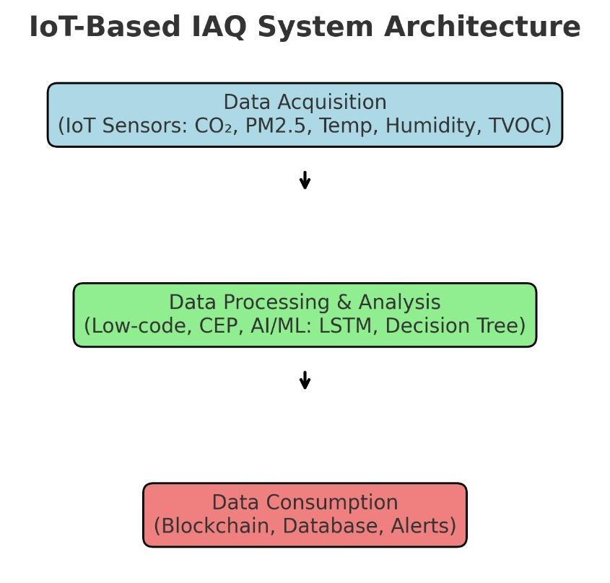
FIG 3.1 IoT-Based IAQ System Architecture.

CHAPTER 4

IMPLEMENTATION METHODOLOGY

The implementation of the proposed IoT-Based Indoor Air Quality (IAQ) Management System involves the integration of hardware devices, software platforms, artificial intelligence models, and secure data storage. The methodology follows a step-by-step design approach, ensuring that each layer of the system architecture is implemented effectively.

4.1 IoT Sensor Network
The Data Acquisition Layer is realized through a Wireless Sensor Network (WSN) deployed in classrooms.
- Microcontroller:
The ATMega256RFR2 8-bit microcontroller is used due to its low power consumption and built-in ZigBee wireless communication capabilities.

Sensors Used:
- SHT31: Temperature and Humidity sensor.
- SCD41: Carbon dioxide (CO₂) sensor.
- SGP30: Volatile Organic Compounds (VOC) sensor.
- SPS30: Particulate Matter (PM2.5) sensor.
Each sensor node collects environmental data and transmits it periodically to a ZigBee coordinator node, which forwards the data to the edge device.
- Advantages:
- Low-cost, self-manufactured hardware.
- Compact design for classroom installation.
- Real-time monitoring of multiple pollutants simultaneously.

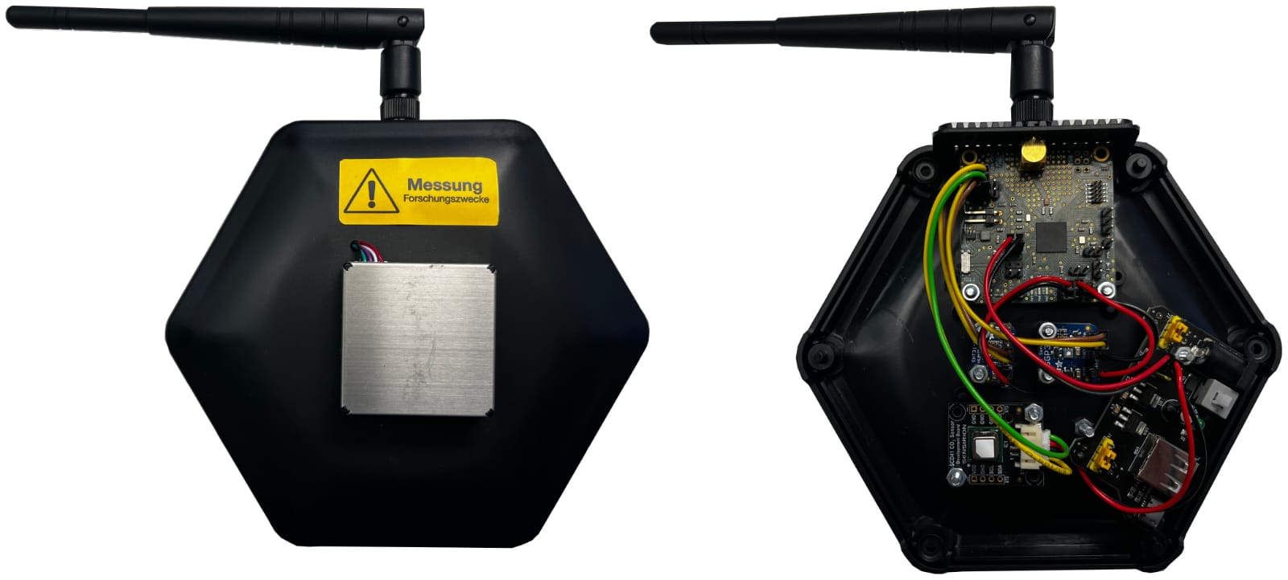
FIG 4.1 The IoT sensor prototype

4.2 Complex Event Processing (CEP)
To enable real-time detection, the Siddhi CEP engine is implemented in the Data Processing Layer.
- CEP continuously receives live data streams from sensors.
- Event patterns are defined (e.g., CO₂ > 2000 ppm → trigger alert).
- CEP correlates multiple inputs (e.g., high CO₂ + high humidity) to detect unsafe IAQ conditions.
- Alerts are generated instantly and forwarded to administrators or displayed on a monitoring dashboard.
This approach ensures that IAQ problems are identified and addressed immediately, rather than waiting for manual analysis.

4.3 Artificial Intelligence Models
Two AI models are integrated for prediction and pollutant analysis:
- Long Short-Term Memory (LSTM):
- Type: Deep learning model (RNN variant).

- Application: Forecasts CO₂, PM2.5, temperature, and humidity for the next 10 minutes using historical data.
- Benefit: Provides early warnings before pollutant levels reach hazardous thresholds.
- Decision Tree Regressor:
- Type: Machine learning model (glass-box model).
- Application: Identifies relationships between pollutants, e.g., predicting PM2.5 levels based on CO₂, humidity, and temperature.
- Benefit: Easy to interpret with if-then rules, aiding administrators in understanding pollutant correlations.
Together, these AI models transform the system from being reactive to proactive.

4.4 Blockchain Integration
The Data Consumption Layer ensures data security and integrity using blockchain technology.
- Blockchain Network: Ethereum testnet.
- Smart Contracts: Automatically store IAQ events when unsafe conditions are detected.
- Benefits:
- Data becomes tamper-proof and auditable.
- Provides trustworthy records of IAQ conditions for compliance.
- Enhances transparency between institutions and stakeholders.
To reduce overhead, only critical IAQ events are stored on the blockchain, while bulk data is stored in a NoSQL database (MongoDB).

4.5 User Interaction and Alerts
- A Node-RED dashboard provides real-time visualization of IAQ data.

- Alerts are sent via messaging platforms (e.g., Telegram Bot) when thresholds are crossed.
- Teachers or administrators can take immediate corrective action such as opening windows or activating ventilation systems.

4.6 Summary of Methodology
The implementation methodology demonstrates a seamless integration of IoT, CEP, AI, and Blockchain into one intelligent framework. The use of low-cost sensors, real-time event detection, predictive AI models, and secure storage ensures that the system is both practical and scalable for educational institutions.

CHAPTER 5

CASE STUDY AND RESULTS
To validate the effectiveness of the proposed IoT-Based IAQ Management System, a real-world case study was conducted in university classrooms. The objective was to monitor indoor air quality under different classroom conditions, evaluate real-time alerting, and test the predictive accuracy of AI models.

5.1 Experimental Setup
- Location: Three lecture and laboratory rooms at the Faculty of Computer Science and Engineering, Frankfurt University of Applied Sciences.
- Duration: Two months of continuous monitoring (July–August 2023).
- Conditions Monitored:
- Empty classrooms.
- Lecture sessions.
- Seminar activities.
- Exam periods (high student occupancy).
IoT sensor stations were installed in each classroom, each containing the following:
- SHT31 (temperature & humidity sensor)
- SCD41 (CO₂ sensor)
- SGP30 (VOC sensor)
- SPS30 (PM2.5 sensor)
The sensors transmitted data via the ZigBee network to an edge node, which forwarded it to the CEP engine and AI models for processing.

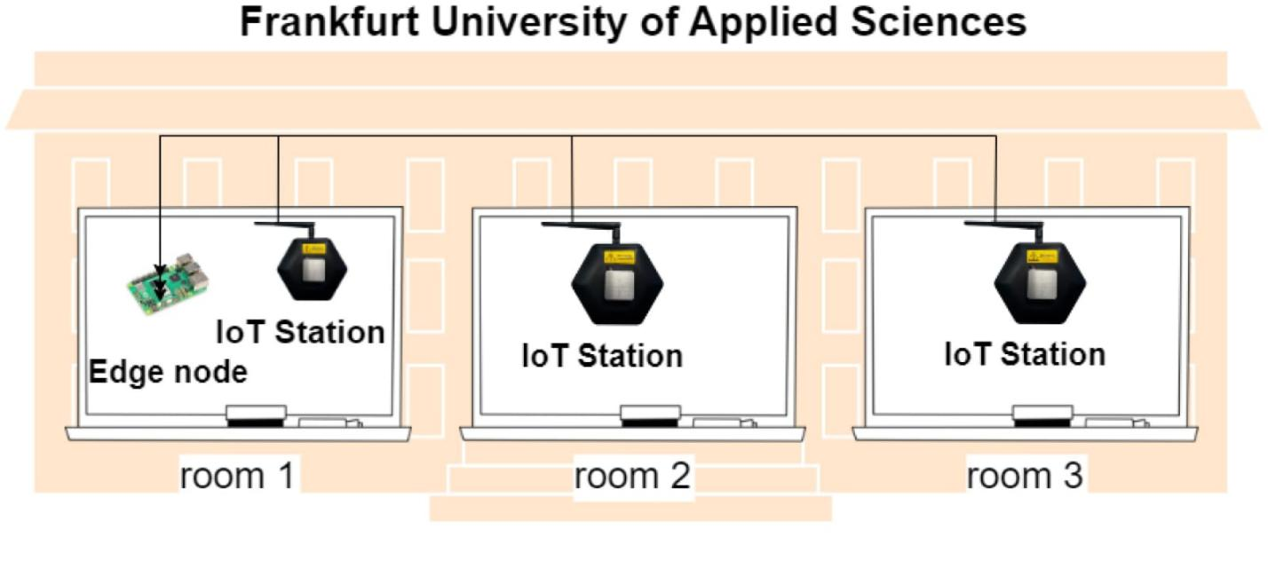
Figure 5.1: Classroom Deployment of IoT Stations
This figure shows the IAQ monitoring setup at Frankfurt University of Applied
Sciences, where three classrooms were equipped with IoT stations for
real-time data collection. Room 1 includes the Edge Node for data aggregation,
while Rooms 2 and 3 contain additional IoT stations for distributed sensing.

5.2 Observations from Classroom Monitoring
The system recorded varying IAQ levels depending on classroom usage:
- Empty classrooms: Normal CO₂ levels (< 800 ppm) and low PM2.5 values.
- During lectures and seminars: Significant increase in CO₂ concentrations (1200–2000 ppm).
- Exam periods: Extreme CO₂ levels above 2000 ppm, indicating poor ventilation and overcrowding.
- Humidity & temperature fluctuations: Higher humidity was observed with increased occupancy, affecting comfort levels.
These findings confirm that occupancy directly impacts IAQ and that continuous monitoring is crucial.

5.3 Real-Time Alerts
The Siddhi CEP engine detected unsafe IAQ conditions and generated alerts when:
- CO₂ > 2000 ppm (dangerous for concentration).
- PM2.5 > 35 µg/m³ (hazardous for respiratory health).
Alerts were sent via Node-RED dashboards and Telegram notifications to administrators, enabling immediate corrective actions such as:
- Opening windows.
- Activating fans or HVAC systems.
- Reducing room occupancy.

5.4 AI Model Predictions
Two AI models were tested:
- LSTM Forecasting Model
- Predicted CO₂, PM2.5, temperature, and humidity 10 minutes ahead using historical data.
- Achieved very low error rates:
- Temperature MAE = 0.07
- Humidity MAE = 0.20
- CO₂ MAE = 3.30
- PM2.5 MAE = 0.19
This accuracy ensured early warnings before unsafe conditions occurred.
- Decision Tree Analysis
- Found clear relationships between pollutants.
- Example: High CO₂ levels often correlated with rising PM2.5 levels, especially in crowded classrooms.

- Provided an easy-to-understand if-then rule set for administrators.
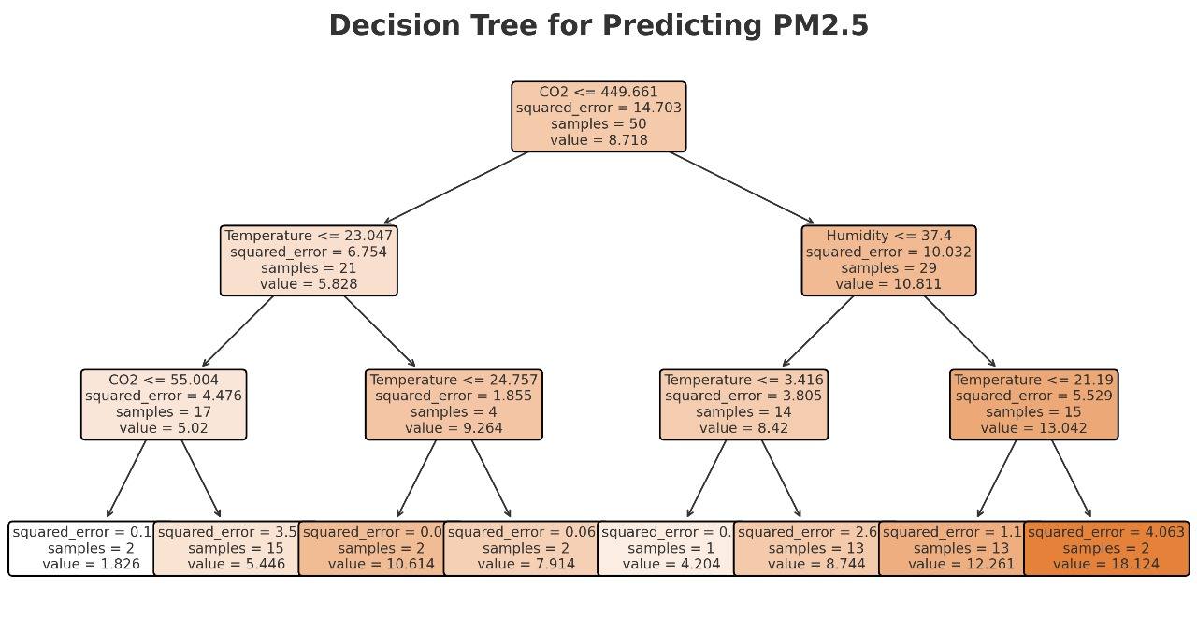Figure X: Decision Tree Regression for Pollutant Prediction
This figure illustrates the trained Decision Tree model used to analyze correlations among IAQ parameters. The tree shows feature splits (e.g., CO₂, temperature, humidity) and prediction values at each node, helping identify key factors influencing pollutant levels.

5.5 Results and Discussion
The system proved effective in:
- Detecting unsafe IAQ in real time using CEP.
- Forecasting pollutant levels with high accuracy using AI.
- Storing events securely in blockchain for transparency and compliance.
- Improving classroom environments by enabling timely corrective measures.
The case study demonstrated that the integrated system can enhance student health, concentration, and academic performance while reducing risks of fatigue and illness.

CHAPTER 6

ADVANTAGES AND APPLICATIONS
The proposed IoT-Based Indoor Air Quality (IAQ) Management System offers several advantages over traditional monitoring systems and is applicable to a wide range of environments. Its low-cost sensor design, predictive intelligence, and secure data storage make it a practical and scalable solution.

6.1 Advantages of the Proposed System
- Real-Time Monitoring:
The system continuously measures IAQ parameters such as CO₂, PM2.5, VOCs, temperature, and humidity. This allows instant detection of unsafe conditions.
- Predictive Intelligence:
With the integration of LSTM and Decision Tree models, the system can forecast air quality and anticipate hazardous conditions before they occur.
- Low Cost and Scalability:
Using self-manufactured IoT sensor nodes and ZigBee-based wireless networking ensures cost-effectiveness. The system can be scaled across multiple classrooms, buildings, or campuses.
- Automated Alerts:
The CEP engine provides automatic detection of abnormal conditions and instantly sends alerts to teachers or administrators, enabling quick intervention.
- Data Security and Transparency:
The use of blockchain technology ensures tamper-proof and auditable IAQ event records. This is particularly important for compliance and long-term monitoring.
- User-Friendly Interfaces:
The integration of Node-RED dashboards and Telegram bot notifications provides administrators with easy access to IAQ status and alerts.

6.2 Applications of the System
The system is designed for educational environments but is versatile enough to be adapted in various domains, including:
- Educational Institutions (Schools and Universities):
To ensure healthy classrooms, improve student focus, reduce absenteeism, and enhance overall learning outcomes.
- Hospitals and Healthcare Facilities:
For maintaining clean indoor air to protect patients and staff, especially in sensitive wards.
- Offices and Workspaces:
To improve employee productivity by preventing fatigue and discomfort caused by poor IAQ.
- Smart Homes:
To provide families with continuous monitoring of indoor pollutants, ensuring well-being and safety.
- Industrial and Factory Environments:
To detect harmful gases and particulate matter, ensuring compliance with safety standards and worker health.
- Smart Cities:
Large-scale deployment of IAQ monitoring systems in schools, hospitals, and public offices can contribute to urban health management and sustainable development.

6.3 Summary
By combining IoT, AI, CEP, and Blockchain, the proposed system is not only a technological innovation but also a practical solution that can transform how institutions and organizations manage indoor air quality. Its adaptability ensures that it can be deployed in any environment where health, safety, and productivity are priorities.

CHAPTER 7

CHALLENGES AND LIMITATIONS
While the proposed IoT-Based Indoor Air Quality Management System demonstrates strong potential for improving classroom health and learning efficiency, several challenges and limitations must be considered during real-world deployment.

7.1 Sensor Accuracy and Calibration
Low-cost IoT sensors, while affordable, may suffer from measurement drift, environmental interference, or noise in readings.
- Regular calibration and maintenance are required to maintain accuracy.
- Differences between classrooms in ventilation and placement may also affect sensor readings.

7.2 Network Reliability
The system relies on the ZigBee wireless protocol, which may face signal interference in large buildings or areas with multiple wireless networks.
- Data packet loss or delays could reduce the reliability of real-time alerts.
- For large-scale deployments, hybrid communication technologies (Wi-Fi, LoRa, 5G) may be needed.

7.3 Scalability Issues
While the system is designed for scalability, adding more classrooms increases:
- Hardware costs (sensors, microcontrollers).
- Complexity in managing data flows.
- Energy consumption for continuous monitoring.

Optimization of power consumption and efficient data aggregation is essential to maintain scalability.

7.4 Blockchain Overhead
The integration of blockchain provides tamper-proof data storage, but it introduces:
- High computational overhead for smart contracts.
- Storage challenges, since large datasets are not practical to store directly on the blockchain.
- Transaction delays when dealing with high-frequency IAQ events.
Thus, only critical IAQ events are stored on blockchain, while bulk sensor data is stored in MongoDB.

7.5 Maintenance Requirements
- Sensors require regular calibration and replacement.
- Battery-powered nodes need periodic recharging or replacement.
- Environmental conditions (dust, humidity) may reduce device lifespan.

7.6 Data Privacy Concerns
As IAQ monitoring involves data collection in educational environments, there are privacy considerations:
- Classroom activity patterns could indirectly be inferred.
- Secure handling and restricted access policies must be enforced.

7.7 Summary
The above challenges highlight the practical limitations of deploying the system in real-world environments. Addressing these issues requires:
- Enhanced sensor reliability and calibration protocols.

- Hybrid communication technologies for larger deployments.
- Blockchain optimization to reduce computational load.
- Stronger data governance and privacy measures.
Despite these challenges, the system remains feasible, scalable, and impactful, with further refinements expected in future research.

CHAPTER 8

FUTURE SCOPE
The proposed IoT-Based Indoor Air Quality Management System provides a strong foundation for monitoring and managing classroom air quality. However, as technology evolves, there are multiple opportunities to expand, refine, and enhance the system to achieve greater efficiency, scalability, and real-world impact.

8.1 Integration with Smart HVAC Systems
Currently, the system provides alerts when unsafe conditions are detected. In the future, it can be integrated with Heating, Ventilation, and Air Conditioning (HVAC) systems for automated corrective action.
- Example: If CO₂ levels exceed 2000 ppm, the HVAC can automatically increase ventilation.
- This would create a fully autonomous indoor air management system.

8.2 Advanced AI and Machine Learning Models
While the system currently employs LSTM and Decision Tree models, future enhancements may include:
- Hybrid AI Models: Combining deep learning with reinforcement learning to optimize predictions.
- Edge AI: Running lightweight AI models directly on edge devices for faster, decentralized processing.
- Adaptive Learning: Models that continuously improve as more IAQ data is collected.

8.3 Expansion of Monitored Pollutants
The present system monitors CO₂, PM2.5, VOCs, humidity, and temperature. Future versions could include sensors for:

- Carbon Monoxide (CO)
- Nitrogen Dioxide (NO₂)
- Ozone (O₃)
- Formaldehyde and other VOCs
This would provide a more comprehensive analysis of indoor environments.

8.4 Large-Scale Deployment
Future research can explore deployment at scale in:
- Entire university campuses with hundreds of classrooms.
- Hospitals and clinics for sensitive patient environments.
- Corporate offices to enhance employee health and productivity.
- City-wide smart infrastructure projects, contributing to smart city initiatives.

8.5 Blockchain Optimization
Future blockchain research may focus on:
- Lightweight consensus mechanisms to reduce computational costs.
- Integration with decentralized storage solutions such as IPFS (InterPlanetary File System).
- Cross-institution data sharing, enabling schools and universities to benchmark IAQ performance securely.

8.6 Energy Efficiency and Sustainability
- Deployment of energy-harvesting IoT nodes powered by solar or ambient energy.
- Optimization of low-power communication protocols for sustainable long-term monitoring.

8.7 Integration with Health Analytics
Future systems can integrate IAQ data with student health records and performance metrics, allowing:

- Correlation between IAQ and concentration levels.
- Predictive models linking air quality to absenteeism or academic results.
- Use of personal wearables (smartwatches, fitness trackers) for holistic health monitoring.

8.8 Summary
The future scope of the proposed system lies in creating an autonomous, intelligent, and sustainable IAQ ecosystem. By integrating AI, blockchain, smart HVAC, and large-scale deployments, the system can play a vital role in shaping healthier classrooms, smarter cities, and safer indoor spaces across the world.

CHAPTER 9

CONCLUSION
Indoor Air Quality (IAQ) plays a critical role in maintaining the health, comfort, and productivity of individuals, especially in educational environments where students spend long hours in enclosed classrooms. Poor IAQ, caused by elevated CO₂ levels, particulate matter, VOCs, and humidity imbalances, directly impacts student concentration, learning efficiency, and overall well-being. Traditional IAQ monitoring systems are limited, often expensive, and reactive rather than proactive.
This seminar report presented an IoT-Based Indoor Air Quality Management System for Intelligent Education Environments, integrating IoT sensors, Complex Event Processing (CEP), Artificial Intelligence (LSTM and Decision Tree), and Blockchain technology into a unified framework.
- The key contributions of this work include:
- Real-time monitoring of multiple IAQ parameters using a low-cost IoT sensor network.
- Automated detection of unsafe conditions through CEP and instant alerting mechanisms.
- Predictive forecasting using AI models, enabling proactive action before air quality deteriorates.
- Secure and tamper-proof storage of IAQ data using blockchain technology.
- Validation through a classroom case study, demonstrating high accuracy in predictions and effective alerting.
The results confirmed that the proposed system not only detects and predicts IAQ changes effectively but also provides practical and scalable solutions for educational institutions. By ensuring healthier classrooms, the system contributes to improved student focus, reduced absenteeism, and enhanced academic performance.
Although challenges such as sensor calibration, blockchain overhead, and scalability issues remain, the system represents a significant step toward smart and sustainable indoor

environments. Future research can focus on advanced AI models, smart HVAC integration, large-scale deployment, and energy-efficient IoT solutions to further improve effectiveness.
In conclusion, the proposed IoT-based IAQ management system demonstrates how technology can transform education spaces into healthier, smarter, and more efficient environments. By ensuring safe air quality, the system supports not only physical well-being but also the cognitive development and success of students—making it an essential innovation for the future of intelligent education.

REFERENCES

[1] N. D. Lane, M. Zhou, F. Z. Dogar, et al., “IoT-Based Indoor Air Quality Management System for Intelligent Education Environments,” IEEE Access, vol. 11, pp. 128795–128809, 2023.
[2] H. Zhu, Y. Chen, and L. Wang, “IoT-enabled AI forecasting for classroom CO₂ monitoring,” Sensors, vol. 22, no. 19, pp. 6543–6556, Oct. 2023.
[3] J. Brazález, A. García, and E. Hernández, “Decision support for indoor air quality using CEP and fuzzy logic,” J. Ambient Intell. Smart Environ., vol. 14, no. 2, pp. 135–148, 2022.
[4] J. Ortiz, R. Martínez, and P. Ramírez, “Microservices-based architecture for real-time air quality monitoring in smart ports,” IEEE Internet Things J., vol. 9, no. 18, pp. 17122–17133, Sept. 2022.
[5] O. Şimsek, B. Yılmaz, and H. Arslan, “A decentralized framework for real-time air quality prediction using deep learning and CEP,” Future Gener. Comput. Syst., vol. 146, pp. 545–558, Apr. 2024.
[6] C. Rosa-Bilbao, D. López, and M. Fernández, “Blockchain-supported event-driven IoT systems for secure air quality monitoring,” IEEE Trans. Ind. Informat., vol. 20, no. 4, pp. 5001–5012, Apr. 2024.
[7] World Health Organization, “Household air pollution and health,” WHO Fact Sheet, 2023. [Online].
[8] R. K. Gupta and S. Agrawal, “Applications of IoT in education: A comprehensive survey,” Int. J. Comput. Appl., vol. 183, no. 16, pp. 1–8, Sept. 2021.
[9] M. S. Islam, R. Want, and Y. Gao, “Smart classrooms: IoT, AI, and blockchain integration,” IEEE Trans. Learn. Technol., vol. 15, no. 6, pp. 982–993, Dec. 2022.
[10] P. K. Dutta and M. Mahfuz, “Blockchain for IoT-based smart environments: A survey,” IEEE Access, vol. 9, pp. 103335–103356, 2021.
[11] A. Sharma, R. Kumar, and M. Singh, “Energy-efficient wireless sensor networks for environmental monitoring: A review,” Environ. Monit. Assess., vol. 195, no. 7, pp. 1–24, 2023.
[12] Y. Li, Z. Zhao, and J. Wang, “Air quality prediction using deep learning: A review,” Atmospheric Environ., vol. 301, 119641, Mar. 2024.

[13] S. Rajendran, H. Gupta, and P. Varma, “Edge computing for real-time IoT analytics,” ACM Comput. Surveys, vol. 56, no. 1, pp. 1–32, Jan. 2024.
[14] D. P. Anderson and L. R. Huang, “Complex Event Processing in IoT environments: Techniques and applications,” Future Internet, vol. 14, no. 4, pp. 89–102, 2022.
[15] L. Zhang, X. Sun, and Y. Chen, “Long short-term memory networks for time-series forecasting of air pollutants,” IEEE Trans. Neural Netw. Learn. Syst., vol. 33, no. 10, pp. 5221–5233, Oct. 2022.

